ĐỀ KIỂM TRA HỌC KÌ I  MÔN: TIẾNG ANH LỚP 9  Thời gian: 60 phút  (Không kể thời gian giao đề)  Mã phách:  Số thứ tự:  Chữ kí của giám thị 1:  Chữ kí của giám thị 2: | Họ và tên: ………………………………..  Trường……………………………………  Lớp: /…………  Phòng thi:…….... Số báo danh:………...
-------------------------------------------------------------------------------------------------------------
Mã phách:

Số thứ tự:
Điểm:
Chữ kí của giám khảo 1:

Chữ kí của giám khảo 2:

MÃ ĐỀ A
- USE OF ENGLISH: (2,0 pts)
Choose the letter A, B, C, or D to indicate the word whose underlined part differs from the other three in pronunciation in the following question. (0.2 point)
1. A. better B. electrician C. event D. congested
Choose the letter A, B, C, or D to indicate the word that differs from the other three in the position of the primary stress in the following question. (0.2 point)
2. A. priority B. embarrass C. concentrate D. delay
Circle the best options. (1,2 point)
3. _______ meals are important for the development of teenagers’ mental and physical health.
A. Priority B. Speciality C. Correct D. Well-balanced
4. Many old buildings in Hoi An have been preserved because they represent a valuable part of the town’s ________.
A. celebration B. event C. memory D. heritage
5. During the bullying incident, I felt so ________ and lonely, unable to defend myself.
A. confident B. crowded C. helpless D. calm
6. Due to the bad weather, the old woman ______ serious illness.
A. came down with B. came on C. came up with D. came back
7. The better the weather is, ______.
A. the most crowded the beaches get B. the most the beaches get crowded
C. the more crowded the beaches get D. the more the beaches get crowded
8. Mary is in Hanoi now, but she ______ Văn Miếu yet.
A. visited B. doesn’t visit C. hasn’t visited D. wasn’t visiting
Choose the best respond (0,2 point)
9. Emma: “We could attend local health workshops to learn about healthy living.”
Nick: “…………. .”
- I don’t like workshops B. That’s sound useful.
- They are probably boring. D. I don’t need to learn about health.
Put the sentences (a, b, c) in the correct order to make a logical text. (0,2 point)
10.
My family decided to spend a relaxing day in the countryside. We packed everything and left early in the morning.
a. However, when we arrived at the picnic spot, we realized that we had forgotten to bring any food.
b. We were so excited about the trip and couldn't wait to have a great time.
c. The drive through the beautiful countryside was peaceful, and we enjoyed the fresh air.
After realizing this, we had to drive all the way back home to get our food.
A b-c-a. B. b-a-c C. a-b-c D.c-a-b
HỌC SINH KHÔNG ĐƯỢC VIẾT VÀO TRANG NÀY, VÌ ĐÂY LÀ PHÁCH SẼ RỌC ĐI MẤT

-----------------------------------------------------------------------------------------------------------------------

- READING: (2,0 pts)
- Read the following announcement and mark the letter A, B, C or D to indicate the correct answer. (0,4 point)
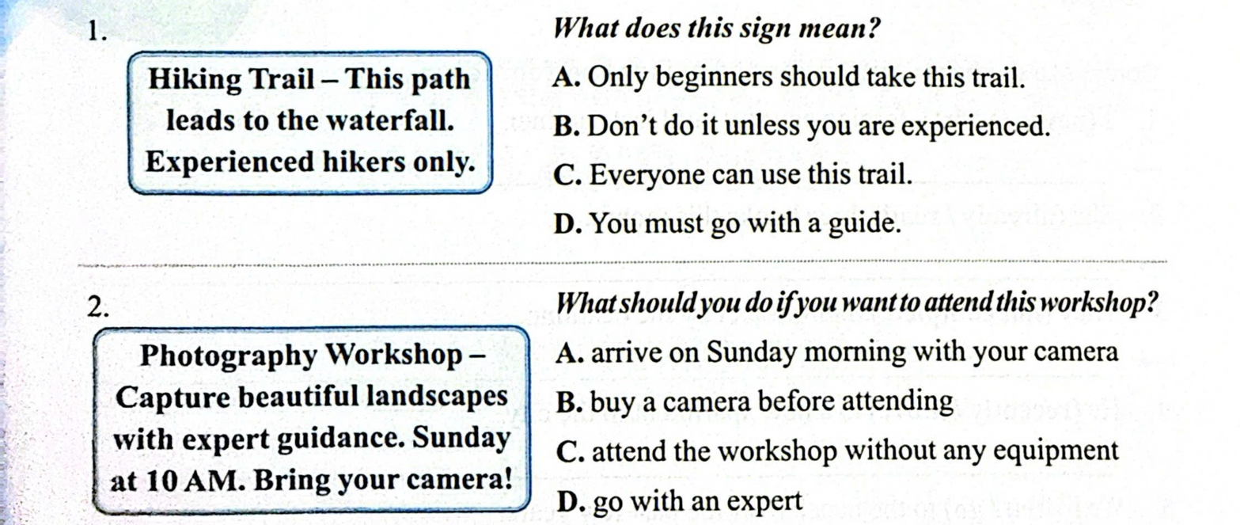
- Read the following passage and circle the letter A, B, C or D to indicate the correct word or phrase that best fits each of the numbered blanks. (0,8 point)
HOW TO SPEND YOUR LEISURE TIME WISELY
1. Plan your day and decide what productive activities (1) __________
2. (2) ___________ priority to outdoor activities and connect with your friends, family and share fun experiences.
3. Avoid concentrating too much (3) __________ your phone or computer.
4. Try to learn something new, such as a skill or hobby, during your free time to keep yourself (4) __________
1. A. doing B. to do C. done D. you do
2. A. Active B. Bring C. Take D. Give
3. A. on B. in C. at D. with
4. A. boring B. happily C. happy D. depressed
III. Read the following passage and choose the letter A, B, C, or D to indicate the correct answer to each of the questions. (0,8 point)
Brighton is a city in the south of England. It’s got a population of about 160,000 and its location has made it a popular destination for tourists.
Brighton is 85 kilometres from London. It’s about an hour on the train. It attracts over 8.5 million visitors annually and is the most favourite seaside destination in the UK for oversea tourists.

I like Brighton because it’s a friendly place and it’s very pretty. There are some really old buildings and it’s got some nice parks. For tourists, there are a lot of interesting shopping areas,

HỌC SINH KHÔNG ĐƯỢC VIẾT VÀO TRANG NÀY, VÌ ĐÂY LÀ PHÁCH SẼ RỌC ĐI MẤT

-------------------------------------------------------------------------------------------------------------

stations, many bus routes, coach services and taxis. In spring and summer, thousands of students from all over Europe gather to attend language courses at many language schools here.
Every time I come here, my favorite places are the beach and the aquarium. For me, Brighton is one of the most beautiful cities in the world.
1. What is the passage mainly about?
A. A country in Europe. B. Old buildings in Brighton.
C. Some beautiful cities in Europe. D. A city in England.
2. According to the passage, what has made Brighton a popular destination for tourists?
A. Its population. B. Its location. C. Its taxis. D. Its trains.
3. The word “gather” in paragraph 3 is CLOSEST in meaning to ______.
A. go away B. come back C. come together D. go on
4. Which sentence is NOT TRUE about Brighton?
A. Students attend language courses at language schools in spring and summer.
B. It is not easy to find a good place to eat in Brighton.
C. It takes an hour to go from Brighton to London by train.
D. Brighton attracts overseas tourists because of being a seaside destination.

C. WRITING: (2,0 pts)
I. Write the correct form of the verbs in the brackets. (0,4 pt)
1. I wish my mum (not/make) ……………. me eat vegetables.
2. I don't know how (get)……………..to the bakery.
II. Rewrite the sentences so as its meaning keeps unchanged. (0,8 pt)
1. They started learning Chinese three months ago. (for)
=> They have……………………………………………………………………….
2. As the city becomes more crowded, the streets get busier.
=> The ……………………………………..………………………………..
III. Write complete sentences from the words given. (0,8pt)
1. My family and I / have / dinner / restaurant / when / we / hear / very / loud noise.
=> .……………………………………………………………………………..
2. Unless / she / finish / project / by / deadline / she / lose / marks.
=> .……………………………………………………………………………..
D. LISTENING: (2,0pts)
I. Listen to the dialogue and fill in the blanks with a word/phrase. You will listen TWICE.
- During the school year, Grandma and her classmates had lessons in the ___________ only.
- They didn’t have much homework and they never had ____________ lessons.
- Some subjects that students didn’t study in the past were music, arts, and ___________ ___________.
- They were walking ___________all the time because they didn't have shoes or sandals.
- During break time, instead of using modern devices, they played ______________ games.

HỌC SINH KHÔNG ĐƯỢC VIẾT VÀO TRANG NÀY, VÌ ĐÂY LÀ PHÁCH SẼ RỌC ĐI MẤT

-------------------------------------------------------------------------------------------------------------

II. Listen and decide if the statements are true (T) or false (F). You will listen TWICE. (1pt)
Statements | True (T) | False (F)
1. Tra is interested in history
2. Nam likes making things with his hands.
3. Nam's family owns a workshop in Bat Trang.
4. The trees in the garden only come from provinces of Viet Nam.
5. Hoa loves nature and quietness.

E. SPEAKING: (2,0pts)
I. Introduction
II. Topic speaking
- Questions and Answer

***** the end *****

